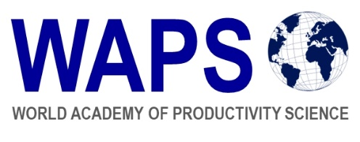

World Academy of Productivity Science
Code of Conduct and Ethics for Fellows and Members

Fellows and Members of the World Academy of Productivity Science are abided by the “WAPS Code of Conduct and Ethics for Fellows and Members”:
1. I will subscribe to the aims and objects of WAPS.
2. I would abide by the policies, Rules and Principles of WAPS.
3. I will promote the cause of SEE Productivity.
4. I would not indulge in any activity that would bring disrepute to WAPS and profession.
5. I will meet the highest standards of competence in the profession.
6. I will deal with stakeholders with utmost integrity and create an environment of Trust.
7. I will be objective in all my actions and decisions and foster fairness.
8. I will ensure that I am always Reliable and Consistent in all my actions.
9. I shall maintain absolute confidentiality.
10. I will ensure that there is no conflict of interest in what I do with any of my stakeholders.

DECLARATION

I, <name of representative>, as Organizational Nominee of <name of organization>, declare that if accepted as an institutional Member of World Academy of Productivity Science (WAPS ), <name of organization> would abide by the WAPS Code of Conduct and Ethics for Fellows and Members.

Date:
Place:
Organization:
Signature:
Name and Title of Representative:

